Plans and Progress

# Introduction

On March 30th, 2021, six total strangers met online for the first time. We came together to investigate careers in IT, learn about technology and come up with an IT project. We came together with six diverse ideas and decided that the best option was a language translation application that allows written translation from one web-enabled device to another using near field communication (NFC). Our application was to be called UMI.

# Early Plans

The first iteration of our project was for an application was a language translation application that could translate messages between people using Near Field communications. Customers would download the application onto their mobile devices. They could then exchange messages in different languages. Our early design work involved having an application available for both android and apple but using a standard back-end design.

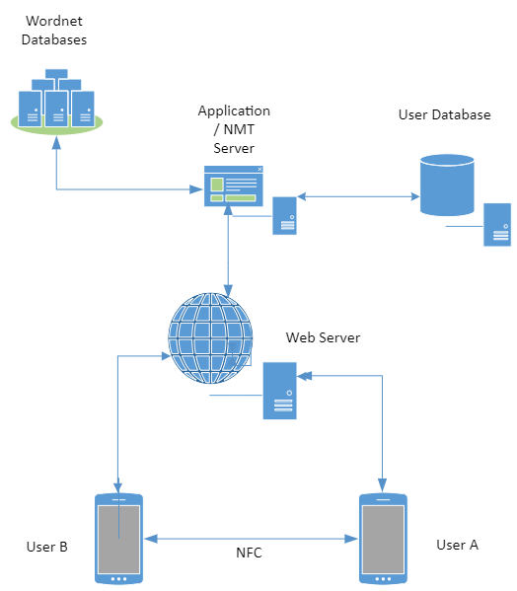

How this design works is that users will download the application onto their device (or, in the case of using a computer, load up the web page). Once the user has reached the landing page, they will then log in to an account (or create one). Once logged in, the user can now submit text or documents they wish to translate into another language.

The application will send uploaded documents to the webserver through the Hypertext transfer protocol (HTTP) server. The web server will then send the documents to the application server, converting, via an API, into SQL data stored onto the user database.

The application will then convert the document into text and send it to the NMT server to translate. The NMT server will use wordnet databases in both the original and target language. The translated text will then return to the application server to convert back into a document. It will be stored on the user database and will be available to the user for future use.

The user will then share the message with anyone they wish, in any language they wish. In addition, the app supports the use of Near Field Communication (NFC) to exchange information between users. So, for example, if a user has a document or message in one language they wish to share with another user in another language, they can submit the original document to the app and then share a link to the second user through NFC. The second user sends a request to the application server, pulls the original text, and then sends it to the NMT server for translation into the second user’s language and then sent to the second user via the web server HTTP link to their device.

However, after investigating how the application would work, asking family, friends, and co-workers, it was decided that getting people to tap phones when they could not communicate would be difficult. There are both real and perceived security threats; the theft of data and cultural misunderstandings would make things particularly difficult. The group decided this would not be a marketable product in the real world.

# UMI 2.0

The team decided that change was needed to create a marketable solution. However, the group decided that the original idea, although flawed, had merit. We floated a new idea, to sell the application to hospitality providers and their customers. The idea being that a customer who does not speak the language of the restaurant menu would be able to download the same menu by simply putting their phone on an NFC reader, and the translated menu would be available on their phone. Then, once they are ready to order, they can tap the phone and send the order back to the restaurant, with any notes or changes, in the language of that restaurant.

We would have to make changes to the front-end design. These include making the app more geared toward a web browser model for restaurants, ensuring that our product could fit into existing infrastructure, and investigating NFC readers that would work on USB. Our approach was now to have two different functionalities: downloading a menu and making an order.

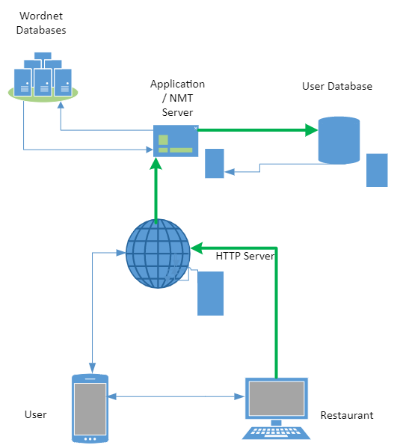

Restaurant use

Restauranteurs will require a computer connected to the worldwide web to log into our HTML web page. From here, they can do things like upload menus, show previous orders, and, most importantly, ensure that billing details are up to date. First, upload the menu to the HTTP server, which then forwards it to the Application server, who then converts it to the SQL format and stores it on the Client database.

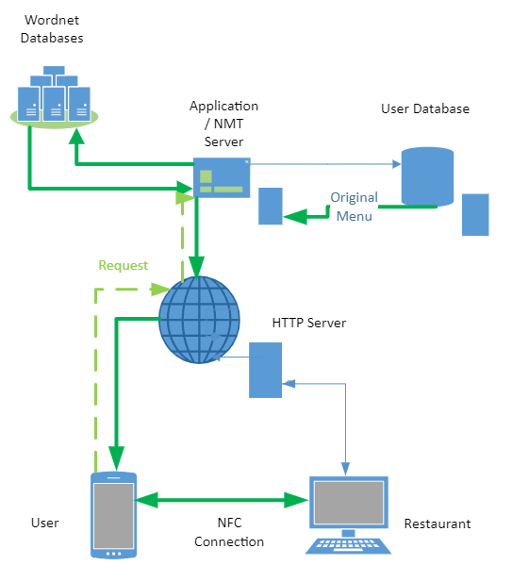

Downloading a menu

The restaurant customer opens the application on their NFC-enabled device and then tapping their phone at the NFC device on the restaurant's counter. A request is then sent through the webserver to the application server to retrieve the restaurant's Menu. Next, the text will be sent, along with the user's language information, to the Neuro Machine translation (NMT) server. The NMT server will then use the NMT algorithm to choose words from the user's language wordnet database to translate the Menu into the user's language. Finally, the app will send a translation to the user via the HTTP server.

# Component details

## Front end development

The front end is the user interface, usually a web page for the restaurant user or through an app on their phone for the customer. Once signed in, the user has a landing screen. From here, they can see their account information in their language. Once the customer requests a menu, a translated version of the menu will be made available. Translation can be done automatically through the App, with the preferred method being a data transfer via near field communication (NFC). Once the device has tapped the NFC hotspot, it will connect to the App's web server and download the menu in the language of the user's choice.

The website and mobile app should be designed and developed in tandem. The development will require the X code coding suite to develop the iPhone App (Ching 2019), Android studio for the Android version (TheZachBales n.d.) In addition, we will create Web pages with a combination of HTML, CSS, and JavaScript (Cox 2020).

## Near Field Communications

Near Field Communication (NFC) devices allow the peer-to-peer transfer of secure information between two clients in the same geographical location (Sauter 2016). Our App is about communication between a hospitality business and potential customers.

As the restaurant side would mainly be using PC or laptops already, there would be a need for them to purchase an NFC reader for around $60(square reader n.d.). To program the NFC Reader for the App, they will need encoded for around 25c per tag with go-to tag encoder (Go To n.d.)

## Web server

## The App requires a connection to the internet to send and receive data from the client to the App's back end. Therefore, we require a Hypertext transfer protocol (HTTP) connection over the world wide web that connects to our web server in the cloud (Schuler 2002). The client can request data such as database information, photos.

## After researching various options, including buying and setting up our server, we decided on using a cloud service. The apache with the ubuntu web server is one the oldest and most popular HTTP server Infrastructure as a service (IAAS) products on the market (AWS 2021, a).

## Application Server and APIs and Customer Database

The application server is the real brains of the operation. It is here that the front-end makes requests for information, and the request is processed. For example, suppose a client wishes to add a document to the database. In that case, the application server will request and add the relevant metadata to ensure the user can access the document in the future. (IT pro team 2018).

Our application server will require us to have an application programming interface (API) between the HTTP server and the Neural Machine Translation sever. Amazon translate is an NMT solution and API that we could use. In addition, Amazon translate is a scalable solution for our product, perfect for our business needs (AWS 2021, b). The project team also looked at possibly using Microsoft Azure, which priced similarly (Azure 2021); however, we decided that Amazon Web Service (AWS) better suited our business growth plan.

We would also require an Application Programming interface to allow our application to customer service information and menu data, billing data, and personal preferences into a logical database system. We decided that the best way forward was to bundle services with AWS, as they were competitive on price, and keeping all our APIs and IAAS in the same company could be beneficial when looking at it from an interoperability perspective. The slash DB product creates automated APIs for relational databases (AWS 2021, c). As a result, we can store and pull data quickly and create new features for our customers.

# Project Deliverables

So far, the project has made many plans and had many discussions around what we plan to do. We are currently working on several deliverables to ensure a smooth transition into the project's next phase. First, we have created a Figma prototype so that potential investors and customers can get a feel for the product before we begin coding. The prototype will be a working mock-up of the phone application, with working buttons and menus.

We have also created a professional video presentation, which will show in detail what the application does. So again, it is another opportunity for all stakeholders and future customers, and potential investors. So again, all members approved the presentation of the team.

Other deliverables include a project scope statement. With a definite project scope, managers can easily stay on track and achieve all deadlines throughout the project life cycle (kiss flow, 2021). The project scope statement defines the limitations of the project, breaks down the work, and ensures that all stakeholders are clear on objectives (kiss flow 2021)

# Future

We intend to divide the project up into 4 phases. The first phase was to bring the group together, develop a workable idea, investigate the design, investigate the tools and technology, and put forward a detailed description of the application. During this time, we also spent time together investigating IT technologies, careers and creating group processed.

Phase 2, the current phase, is about refining our output. We have set ourselves key deliverables and achieved in the production of those. We have refined our product, investigating ways to improve the implementation of the translation service and how to develop a working prototype in phase 3

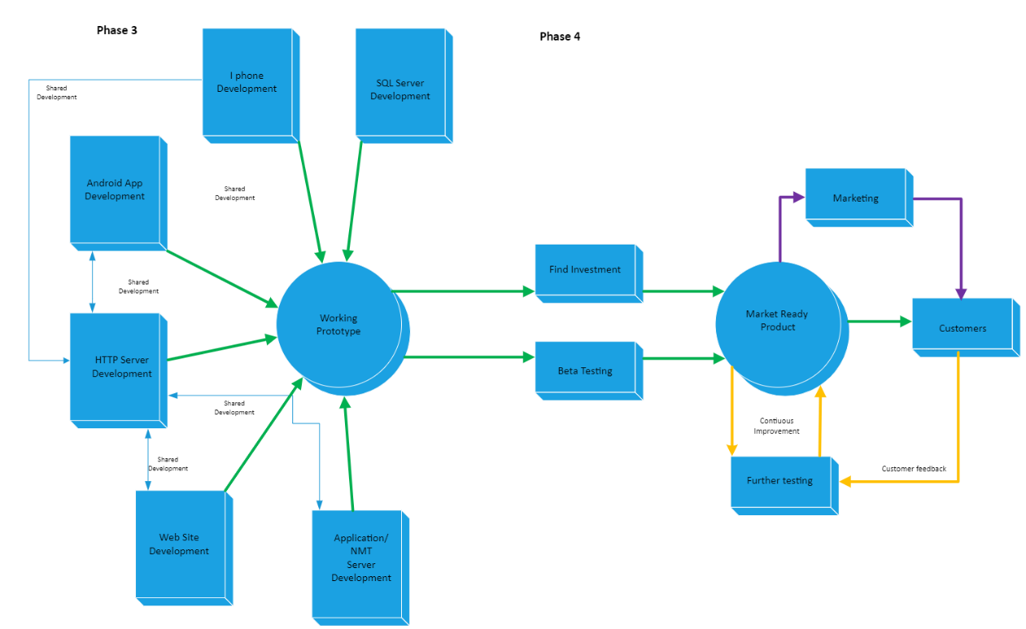

Context diagram for phase 3 and phase 4

Phase 3 is mainly concerned with the creation of a working prototype. We expect that this will take take place over ten weeks, from the 31s of May through to 6th August 2021. The idea would be to divide up the team between the front-end and back-end development. Thus, the project would run as a series of sprints—goals for each sprint to back up the overall aim.

Phase 4 is the final stage and involves taking the working prototype and creating a market-ready product. The most crucial part is in this beta testing. Testing will allow the team to make improvements and refine the code to be the best it can be at launch. The phase will last from 8th August until a launch date that will be 8th February 2022

Ching, C 2019, X code tutorial for beginners, Coding with Chris, viewed 9 April 2021, <https://codewithchris.com/xcode-tutorial/>

TheZachBales n.d., How to create and android app with android studio, instructable circuits, viewed 9 April 2021, <https://www.instructables.com/How-To-Create-An-Android-App-With-Android-Studio/>

Cox, K L 2020, Web Design 101: How HTML, CSS, and JavaScript Work, Hubspot, viewed 5 May 2021, <<https://blog.hubspot.com/marketing/web-design-html-css-javascript#:~:text=HTML%2C%20CSS%2C%20%26%20JavaScript%3A,the%20behavior%20of%20different%20elements>>

Sauter, D 2016, Using Near Field Communicatons, Rapid Android Deployment, Viewed 4 May 2021, <https://www.mobileprocessing.org/nfc.html>

Square reader n.d., Square reader, Square POS, viewed 5 May 2021, <https://squareup.com/shop/hardware/au/en/products/chip-credit-card-reader-with-nfc-au?device=c&gclid=Cj0KCQjwyN-DBhCDARIsAFOELTno1kT_SWQzop1d4VsBfurmOWZ8FLIZ61LWmsqg9xdyLK4elwMAM1UaAgnuEALw_wcB&gclsrc=aw.ds&h=https%3A%2F%2Fsquareup.com%2Ft%2Ff_online%2Fd_search%2Fp_google%2Fc_pla%2Fl_au%2Fdt_alldevice%2Fpr_r12%2Fgclid%3DCj0KCQjwyN-DBhCDARIsAFOELTno1kT_SWQzop1d4VsBfurmOWZ8FLIZ61LWmsqg9xdyLK4elwMAM1UaAgnuEALw_wcB%2F%3Froute%3D%2Fshop%2Fhardware%2Fau%2Fen%2Fproducts%2Fchip-credit-card-reader-with-nfc-au%26gclsrc%3Daw.ds%26%2Fgclid%3DCj0KCQjwyN-DBhCDARIsAFOELTno1kT_SWQzop1d4VsBfurmOWZ8FLIZ61LWmsqg9xdyLK4elwMAM1UaAgnuEALw_wcB%7Cpub%3DGOOGLE%7Ckw%3DPRODUCT_GROUP%7Ckwid%3Dp55598997216%7Cmatchtype%3D%7Cdevice%3Dc&kw=PRODUCT_GROUP&kwid=p55598997216&matchtype=&pcrid=447205268335&pdv=c&pkw=&pmt=&pub=GOOGLE>

Go To n.d., Encode NFC Tags, Go To Tags, viewed 5 May 2021, <https://gototags.com/encoder>

Schuler, R 2002, How does the internet work?, Pomeroy IT studios, viewed 5 May 2021, <http://web.stanford.edu/class/msande91si/www-spr04/readings/week1/InternetWhitepaper.htm#:~:text=HTTP%20is%20a%20connectionless%20text,be%20made%20for%20each%20request.>

AWS 2021, Apache Web server with ubuntu 18.04, Amazon Web Services, viewed 5 May 2021, <https://aws.amazon.com/marketplace/pp/B082XJD2RW?qid=1618209672009&sr=0-2&ref_=srh_res_product_title>

IT Pro team 2018, What is an application server, IT Pro, viewed 6 May 2021 <https://www.itpro.co.uk/strategy/29643/what-is-an-application-server>

AWS 2021 b, Amazon Translate features, Amazon Web Services, viewed 7 May 2021, <h[ttps://aws.amazon.com/translate/details/](https://aws.amazon.com/translate/details/)>

Azure 2021, Cognitive service pricing, Microsoft Azure, viewed 6 May 2021 <https://azure.microsoft.com/en-us/pricing/details/cognitive-services/translator/>

AWS 2021, c, SlashDB - Automatic REST API for Databases, Amazon Web Services, viewed 6 May 2021, <https://aws.amazon.com/marketplace/pp/B00FFKW0GC>

Kissflow, 2021, What is a project scope statement and why is it important, Project, viewed 5 May 2021, <https://kissflow.com/project/project-scope-management/#:~:text=With%20a%20definite%20project%20scope,you%20are%20already%20mid%2Dway>